EMBRAER PRAETOR 600 NEW Special AOC Package
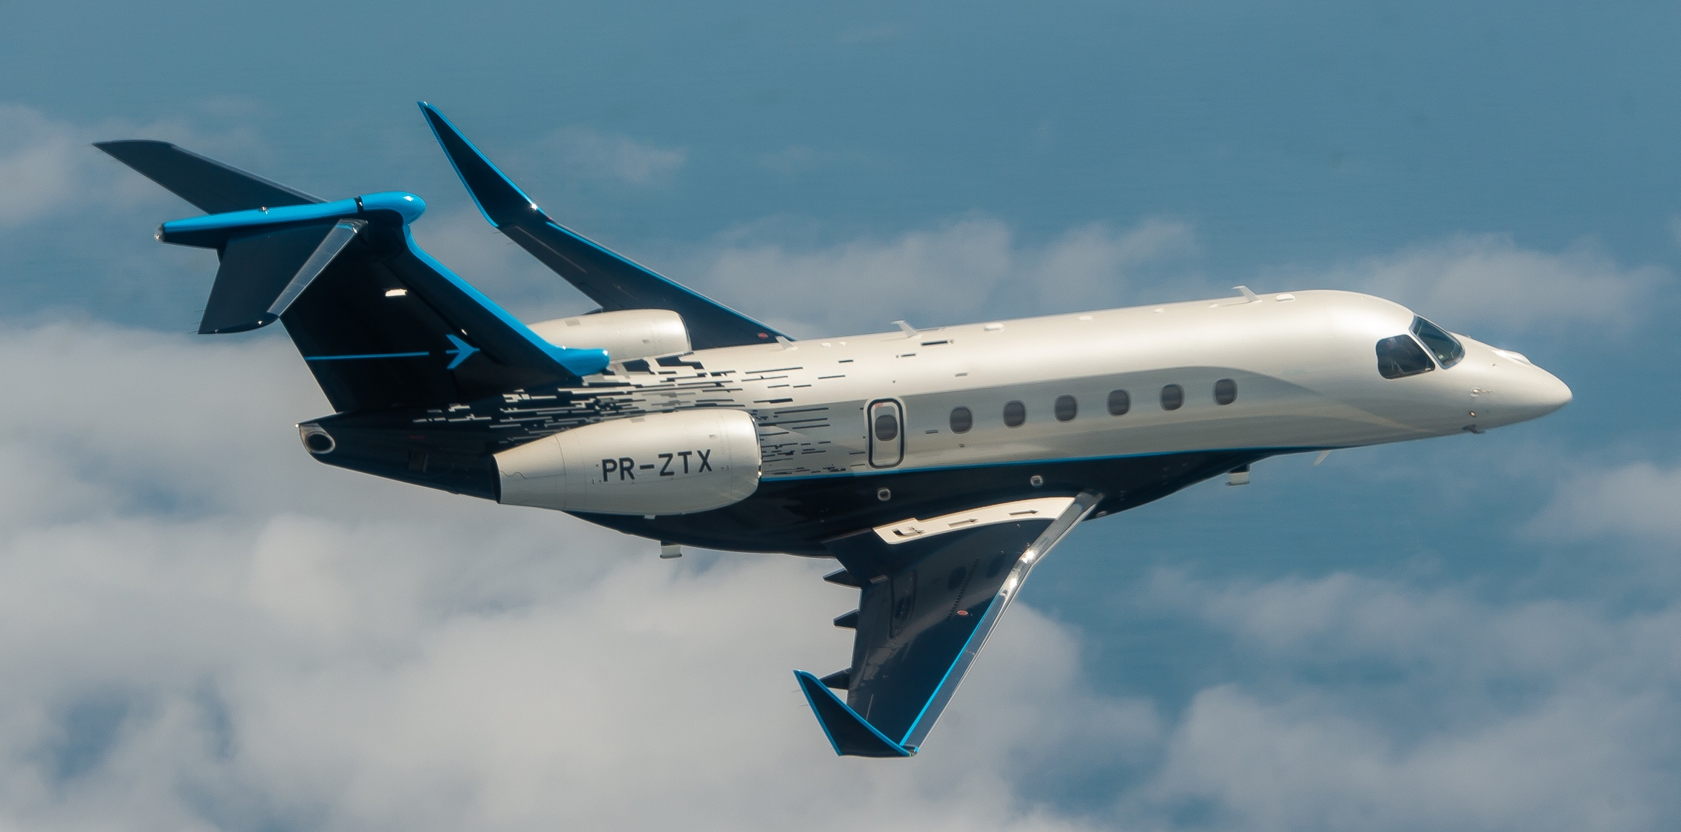
Embraer © Pictures for illustration only – colors and paint schemes at your choice

Commercially operated in German AOC with Charter Income – Smart Investment.
Mono Fleet Concept. Fast and easy enrolment:

• No enrolment cost

• Experienced pilots

Ask for Operational Proposal – Just buy and fly!

FEATURES

4,018 NM / 7.440 km Range

London – New York or London – Dubai non-stop

Fly-by-Wire & Auto Throttle & Auto Brake
- LPV approaches, ADSB out, CPDLC over ATN (EASA Link2000+) and FANS 1/A+ CPDLC Package
- Lightning Detection System
- Predictive Wind Shear System (PWS) & Vertical Weather (VWX)
- Surface Management System
- Paperless Cockpit
- Steep Approach (approved at London City Airport)
- Provisions for EVS - Enhanced Vision System &
for HUD - Head Up Display / Installation at owners wish

CABIN
- VIP – 9 Seat Cabin Arrangement in your color specifications
4 passenger club arrangement plus 2 club seats plus 3-place-divan,
- Galley with oven/microwave, coffee maker, refrigerator and CA seat
- Fully enclosed lavatory and wardrobe/cabin baggage storage
- Stone floor on entrance/galley and lavatory floors
- Enhanced Cabin Management System plus Upper Tech Panel
- Heating system for Baggage Compartment
- Iridium Satellite Phone
- Leather, panels and woodworks according your color specification

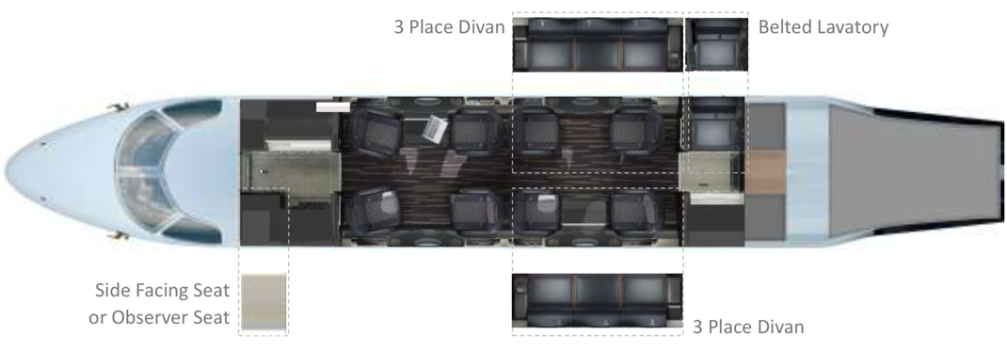
FLY SMART: no need for a heavy jet for long range due to fuel-efficient engines and fine-tuned aerodynamics. That makes the PRAETOR 600 the greenest business jet and a game changer. The PRAETOR 600 amazes passengers with its inviting cabin with a 1.83 m ceiling, a flat floor, low
cabin noise level and smooth ride by a special turbulence-reduction feature. With a fully equipped galley, convenient restroom with wardrobe and cabin luggage storage, seats transforming to 4 flat beds the PRAETOR 600 is the ideal airplane to be used for long flights but also lands on short runways like La Môle St. Tropez.
The state-of-the-art airliner equipment assures a safe flight with highest technology standards.

AirGO SERVICES
The supervision of the process from purchase of your PRAETOR 600 to the start of operation is a complementary service included in the AirGO management contract. Under the mandate the AirGO CAMO is fully responsible for maintenance tracking and supervision. The 24-h Sales & OPS Team organize your flight as well as third party charter; schedules crews and takes care of your special wishes while the approved AirGO Training Organization takes care of continuous pilot training.

AirGO is committed to sustainability. We work only with the most efficient aircraft in its class as well as taking part in programs off-setting CO2, promoting SAJF (Sustainable Alternative Jet Fuel) and working towards environmentally friendly practices in all areas of service. AirGO avoids the use of plastic wherever possible and promotes to remove plastic packaging completely.

